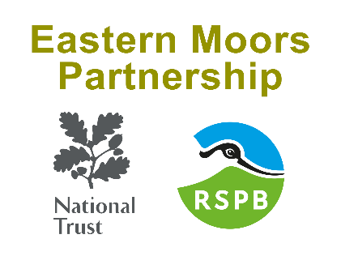
Outdoor Active Provider Scheme
Event Application Form

Please complete the form below and return it with a route/event map to
Natasha.Edgington@easternmoors.org.uk

Event title |  |  |  |  | CODE  (office use only)
Event date |  | Times
Activity (fell run, mountain biking, horse ride etc) |  |  | Number participants
 |  |  | Number of helpers on the day
Event Zone Maps covered by route
Organiser name
Contact details
Postal address
Email address
Phone number
Phone number on the day of the event
Organisation/
business
Event detail
Signing and marshalling: Please provide details and locations of signing and marshalling. These can also be included on your map. There should be at least one marshal on each gate for the duration of the event to ensure gates are closed and latched replaced.
Parking/public transport arrangements: Please provide details. Please ensure adequate parking has been arranged for organisers, marshals, participants and spectators.
Structures, gazebos and breaking the ground: Please provide details including locations
Will dogs be allowed as part of the event? (If yes, dogs should be kept on a lead and restricted to Public Rights of Way during bird breeding season which is between the 1 March and 31 July.)
Please provide details:
Do you give permission for us to pass your contact details to relevant tenants to contact you if they have any event/route concerns or advice?
Please provide contact details for tenants if different from above.
Map attached? Maps must be of high quality, showing the National Trust land boundary as well as the route, markers, out of bounds areas, congregational areas and marshals, hydration points, temporary structures, car parking and a key. Maps must be equivalent to a 1:25 OS map or orienteering map. A link to an on-line map is not sufficient. If your event leaves public rights of way on SSSI land, we may need to apply for Natural England consent. In this instance the SSSI area boundary will also need to be shown on your map (see Natural England Guidance).

